
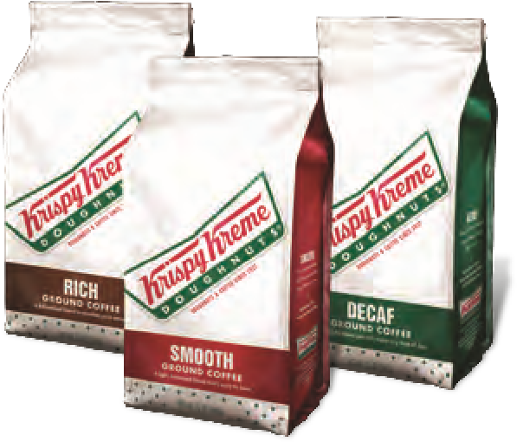
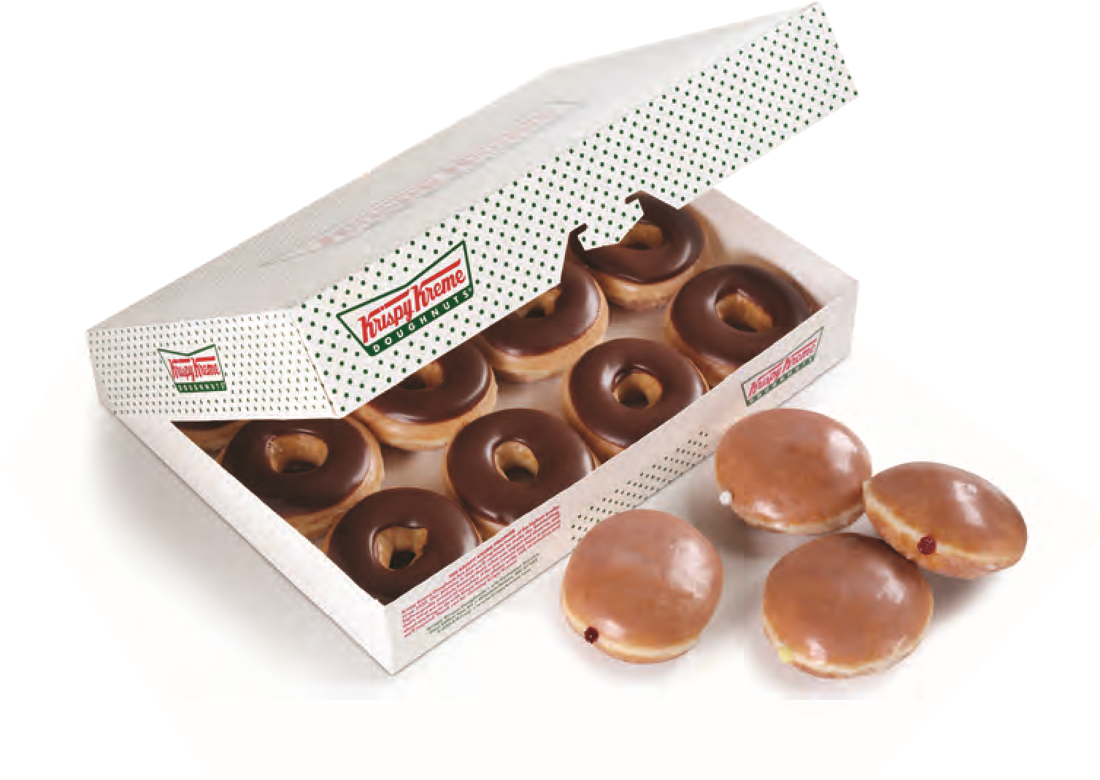
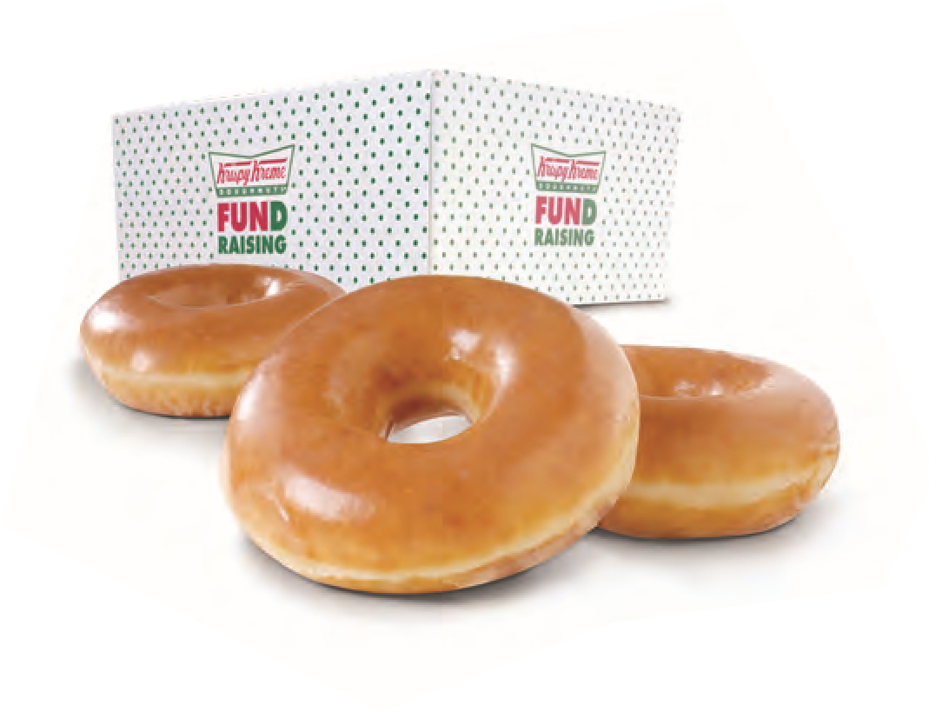

©2014 KKDC
DOUGHNUTS TO
SUIT YOUR TASTE
SPECIAL VARIETY DOZENS
Chocolate Iced
Lemon Filled
Raspberry Filled
Kreme Filled
*ONE VARIETY PER DOZEN
PER DOZEN
PER DOZEN
PER BAG
Classic, Decaf & Bold
ORIGINAL GLAZED
®
DOUGHNUTS
SIGNATURE
COFFEES
12.00
Starts: May 14, 2026
Ends: June 18, 2026
20.00
18.00
Orders expected to be delivered on Thursday, June 25, 2026. All orders must be picked up; no orders can be held.
If you have any questions or want to pay by phone, please call Dezaray at 973-538-8822.

